A. Create your subgroup and project in GitLab using the provided web link by doing the following:
• Clone the project to the IDE.
• Commit with a message and push when you complete each requirement listed in parts D and E.
Note: You may commit and push whenever you want to back up your changes, even if a requirement is not yet complete.
• Submit a copy of the GitLab repository URL in the "Comments to Evaluator" section when you submit this assessment.
• Submit a copy of the repository branch history retrieved from your repository, which must include the commit messages and dates.
C:\Users\warre\OneDrive\d603-machine-learning>git log --oneline --decorate --all --graph --date=short --pretty=format:"%h %ad %an %d %s"
* e6b8ad1 2025-05-31 Warren Buenarte (refs/stash) WIP on task-3: cdf888e fixed the encoding types
|\
| * e225b40 2025-05-31 Warren Buenarte index on task-3: cdf888e fixed the encoding types
|/
* cdf888e 2025-05-31 Warren Buenarte (HEAD -> task-1, origin/task-1, task-3) fixed the encoding types
* 73b3afd 2025-05-31 Warren Buenarte ran classifcation report (training set) and shows AUC-ROC and confusion matrix
* 3e885cd 2025-05-31 Warren Buenarte ran the intial model validation set and optimized model test dataset
* fd7afdc 2025-05-31 Warren Buenarte performed k-fold cross validation to optimize hyperparameters
* db247c7 2025-05-31 Warren Buenarte trained the model and evaluated on validation set
* 7f0b2c3 2025-05-31 Warren Buenarte Cleaned data and applied correct encoding for D3 and D4 in the notebook
:1. Propose one question relevant to a real-world organizational situation that you will answer using one of the following classification methods:
• Random forest
• AdaBoost
• Gradient boost
Can we predict whether a patient is at high risk for readmission to the hospital within 30 days based on their medical history and demographic data?

2. Define one goal of the data analysis. Ensure that your goal is reasonable within the scope of the scenario and is represented in the available data.
The goal is to develop a classification model that identifies patients at high risk of readmission. This will help the hospital chain implement targeted interventions to reduce readmission rates and avoid penalties from CMS
C. Explain the reasons for your chosen classification method from part B1 by doing the following:
1. Explain how the classification method you chose analyzes the selected dataset. Include expected outcomes.
Random Forest is chosen because:
It handles both categorical and continuous variables effectively.
It is robust to overfitting, especially with large datasets.
It provides feature importance, which helps in understanding the key factors influencing readmission.
2. List the packages or libraries you have chosen for Python or R, and justify how each item on the list supports the analysis.
pandas: For data manipulation and preprocessing.
numpy: For numerical operations.
scikit-learn: For implementing the Random Forest model, splitting datasets, and evaluating metrics.
matplotlib/seaborn: For visualizing data and results
D. Perform data preparation for the chosen dataset by doing the following:
1. Describe one data preprocessing goal relevant to the classification method from part B1.
The goal is to clean and transform the dataset to ensure it is suitable for the Random Forest model. This includes handling missing values, encoding categorical variables, and selecting relevant features.
2. Identify the initial dataset variables that you will use to perform the analysis for the classification question from part B1, and classify each variable as continuous or categorical.
Target Variable:

ReAdmis (categorical: yes/no)
Predictor Variables:

Categorical:
Gender (binary)
Initial_admin (nominal)
HighBlood (binary)
Stroke (binary)
Complication_risk (binary)
Overweight (binary)
Arthritis (binary)
Diabetes (binary)
Services (nominal)
Continuous:
Age
Initial_days
TotalCharge
Additional_charges
VitD_levels
Doc_visits
3. Explain each of the steps used to prepare the data for the analysis. Identify the code segment for each step.
The first step in preparing the dataset was to load the data from an Excel file using the pandas library. This was accomplished with the pd.read_excel() function, which reads the file into a DataFrame for further processing. After loading, it was important to address any missing values to ensure the dataset was complete and suitable for machine learning. I used the forward fill method (data.fillna(method='ffill', inplace=True)), which propagates the last valid observation forward to the next valid value. This approach is effective for time-ordered or sequential data and helps prevent the loss of valuable records due to missing entries.
b. Identify and Encode Categorical Variables
The dataset contains both binary and nominal categorical variables. Binary categorical variables, such as Gender, HighBlood, Stroke, Complication_risk, Overweight, Arthritis, and Diabetes, were encoded using LabelEncoder from scikit-learn. This encoder transforms each binary category into a numeric value (0 or 1), making them suitable for machine learning algorithms that require numerical input.
For nominal categorical variables, specifically Initial_admin and Services, one-hot encoding was applied using pd.get_dummies(). One-hot encoding creates a new column for each unique category in the nominal variable, assigning a value of 1 if the observation belongs to that category and 0 otherwise. The drop_first=True parameter was used to avoid multicollinearity by dropping the first category in each set.

c. Select Relevant Features

After encoding, I selected only the relevant features for modeling. This included all continuous variables, the encoded binary variables, and all one-hot encoded columns generated from the nominal variables. The selection was performed by explicitly listing the continuous and binary columns, and then programmatically adding all columns that start with Initial_admin_ or Services_ (the one-hot encoded features). The target variable, ReAdmis, was separated from the predictors.
d. Save the Cleaned Dataset
To ensure reproducibility and facilitate further analysis, the cleaned dataset—containing only the selected features and the target variable—was saved as a CSV file. This allows for easy sharing and consistent use of the prepared data in subsequent modeling steps.
e. Splitting the Data
For robust model evaluation, the data was split into training, validation, and test sets. This was done using scikit-learn’s train_test_split function. First, the data was split into a training set (70%) and a temporary set (30%). The temporary set was then split evenly to create validation and test sets (each 15% of the total data). This approach ensures that the model is trained, validated, and tested on separate data, reducing the risk of overfitting and providing a more accurate assessment of model performance. Each split was saved as a separate CSV file for reproducibility.

4. Provide a copy of the cleaned dataset.
E. Perform the data analysis and report on the results by doing the following:
1. Split the data into training, validation, and test datasets and provide the file(s).
Training is 70%, test is 15%, validation is 15%
2. Create an initial model using the training dataset and provide a screenshot of the following metrics:
• accuracy
• precision
• recall
• F1 score
• AUC-ROC
• confusion matrix
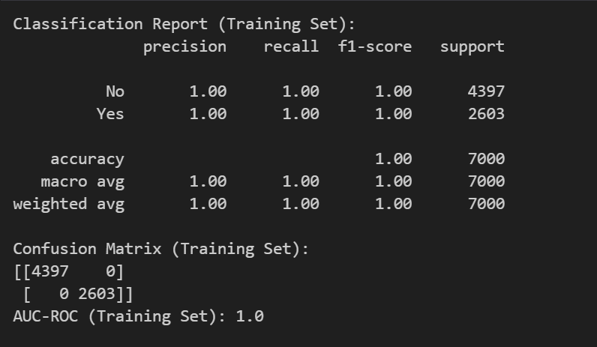
3. Perform hyperparameter tuning on the validation dataset using k-fold cross validation to find the optimized model. Provide the following in the submission:
• identification of which hyperparameters were selected for tuning
• justification of the selection of these hyperparameters
• screenshot of the best hyperparameters
Hyperparameters Selected for Tuning
- n_estimators: Number of trees in the forest. Increasing this value can improve model performance but also increases computation time.
  - Values tested: [100, 200, 300].
- max_depth: Maximum depth of each tree. Limiting the depth can prevent overfitting.
  - Values tested: [10, 20, None].
- min_samples_split: Minimum number of samples required to split an internal node. Higher values can make the model less complex.
  - Values tested: [2, 5, 10].

Justification for Hyperparameter Selection
- n_estimators: Controls the number of decision trees in the forest. A higher number generally improves accuracy but increases training time.
- max_depth: Prevents overfitting by limiting the depth of trees. Testing different depths helps balance bias and variance.
- min_samples_split: Controls the minimum number of samples required to split a node. Higher values reduce overfitting by creating simpler trees.
4. Use the optimized model identified in part E3 to make predictions using the test dataset and provide a screenshot of the following metrics:
• accuracy
• precision
• recall
• F1 score
• AUC-ROC
• confusion matrix
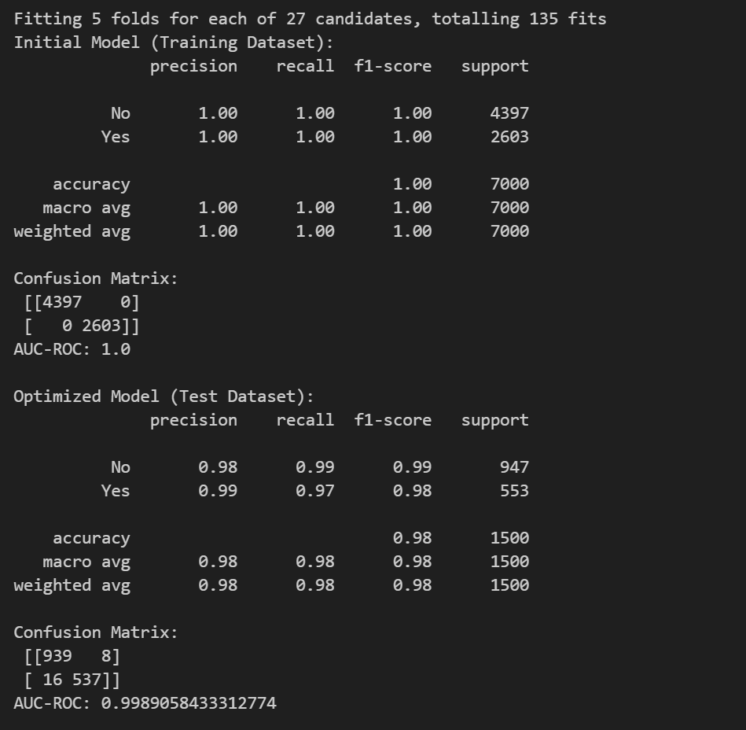
F. Summarize your data analysis by doing the following:
1. Compare and discuss the metrics of accuracy, precision, recall, F1 score, and AUC-ROC from the use of the optimized model on the test dataset and the initial model on the training dataset to evaluate the performance of the optimized model.
The initial model, evaluated on the training dataset, achieved perfect scores across all metrics:

Accuracy: 1.00
Precision: 1.00
Recall: 1.00
F1 Score: 1.00
AUC-ROC: 1.00
Confusion Matrix: No misclassifications (all predictions correct).
These perfect results indicate that the model has likely overfit the training data, learning it exactly rather than generalizing to new, unseen data.

The optimized model, evaluated on the test dataset, achieved the following:

Accuracy: 0.98
Precision: 0.98 (No), 0.99 (Yes)
Recall: 0.99 (No), 0.97 (Yes)
F1 Score: 0.99 (No), 0.98 (Yes)
AUC-ROC: 0.999
Confusion Matrix: Only 24 misclassifications out of 1500 samples.
These results show that the optimized model performs extremely well on unseen data, with very high accuracy, precision, recall, F1 score, and AUC-ROC. The slight drop in metrics compared to the training set is expected and indicates that the model is not overfitting and is generalizing well.

In summary:

The initial model’s perfect scores on the training set are unrealistic for real-world performance and suggest overfitting.
The optimized model’s high but slightly lower scores on the test set demonstrate strong generalization and reliability for predicting patient readmission risk in practice.
The optimized model is preferred for deployment, as its performance on unseen data is a more accurate reflection of real-world effectiveness.

2. Discuss the results and implications of your classification analysis.
The classification analysis shows that the optimized Random Forest model can effectively identify patients at high risk of readmission. This enables the hospital to proactively target interventions, such as follow-up appointments or additional care, for those most likely to be readmitted. By focusing resources on high-risk patients, the organization can reduce readmission rates, improve patient outcomes, and avoid financial penalties.
3. Discuss one limitation of your data analysis.
One limitation of this analysis is the absence of information regarding the reason for the patient’s initial hospital admission. This missing variable could be a significant predictor of readmission risk, and its exclusion may limit the model’s predictive power and the interpretability of the results.
- Recommend a course of action for the real-world organizational situation from part B1 based on your results and implications discussed in part F2.
The hospital deploy the optimized Random Forest model to identify high-risk patients at discharge. The organization should use these predictions to schedule follow-up care, provide targeted support, and allocate resources efficiently. Additionally, collecting and incorporating data on the reason for initial admission in future analyses could further improve model performance and actionable insights.

There were no sources used

